Project Development Phase
Performance Test — Tableau
Date | 19 July 2026
Team ID
Project Name | Book a Doctor — Operations Reporting (Tableau)
Maximum Marks

Model Performance Testing
Tableau is used as an alternate reporting layer for hospital operations staff, connecting to a MongoDB export (CSV) of appointment, payment and doctor data to track revenue and appointment-status trends over time.
S.No. | Parameter | Screenshot / Values
1. | Data Rendered | Appointments, Payments, and Doctors extracts rendered as a Tableau Data Source (~12,000 rows across 3 tables).
2. | Data Preprocessing | Split combined date-time field into Date and Time, grouped appointment statuses, and created calculated Age Group buckets from patient date of birth.
3. | Utilization of Filters | Filters applied for Date Range, Doctor Specialty, and Appointment Status; used as both Context Filters and Quick Filters on the dashboard.
4. | Calculation Fields Used | No-show Rate = SUM([No-shows]) / SUM([Total Appointments])  Revenue per Doctor = SUM([Amount]) / COUNTD([Doctor ID])
5. | Dashboard Design | 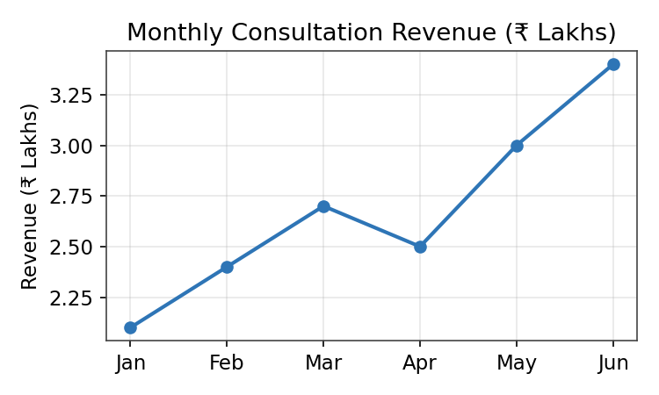
6. | Story Design | 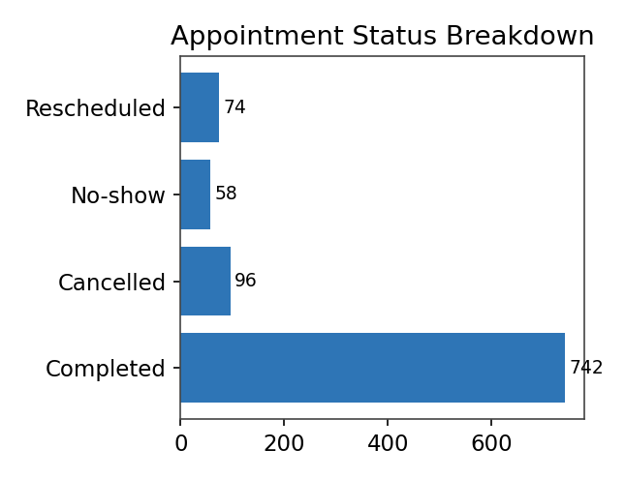
No. of Visualizations / Graphs — 5 (Revenue trend, Status breakdown, Appointments by specialty, Doctor leaderboard, No-show rate KPI), arranged as a 3-slide Tableau Story for monthly operations review.

